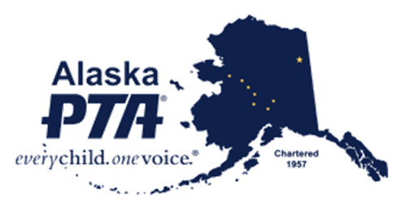
Join the Alaska PTA VIP unit
“Every Child, One Voice”

The Mission of the pta
- To support and speak on behalf of children and youth in the schools, in the community, and before government bodies and other organizations that make decisions affecting children.
- To assist parents in developing the skills they need to raise and protect their children.
- To encourage parent and public involvement in the schools of this nation.

THE PURPOSES OF THE PTA
- To promote the welfare of the children and youth in home, school, community and place of worship.
- To raise the standards of home life.
- To secure adequate laws for the care and protection of children and youth.
- To bring into closer relation the home and the school, that parents and teachers may cooperate intelligently in the education of children and youth.
- To develop between educators and the general public such united efforts as will secure for all children and youth the highest advantages in physical, mental, social and spiritual education.

what is vip membership?
The Alaska PTA VIP unit is a statewide unit, primarily for those who are not members of a local PTA/PTSA unit. Membership is open to any individual, business, organization or coalition member that shares the Mission and Purposes of PTA.

vip members receive:
- Membership card giving you Web access to the Member’s Only sections of the National PTA website (www.pta.org)
- E-mail subscription to the Alaska PTA newsletter and notices.
- Invitations to Alaska PTA & National PTA events with special membership discounts for the events.
- National and State negotiated membership discounts and specials with partners.
- The Voice of over 7500 members.

Join alaska pta vip unit

Name: _______________________________________________________________________

Address: _______________________________________________________________________

City: _______________________ State: ________ Zip: ___________________

Phone: ______________________ Email:________________________________________

I would like to be a voting member:

Yes_______ No ________

I would like to receive information on Alaska PTA Business Partnership opportunities.

Yes_______ No ________

I would like to receive information on starting a PTA in my school or community.

Yes_______ No ________

VIP Membership $10.00
Additional Donation $_______
Total Enclosed $_______

Make checks payable to Alaska PTA
Credit Cards will be accepted via phone or in person at Alaska PTA office.
“Every Child, One Voice”

Alaska PTA

PO Box 201496
Anchorage, AK 99520
555 Northern Lights Blvd Suite #204
907-279-9345 Phone
1-888-822-1699 Toll Free
office.akpta@gmail.com
www.alaskapta.org

